You have a source table **TABLE1** with updated values

You want to update the values in the destination table TABLE2

You will use an OLE DB Command

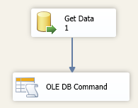

Configure the OLE DB Command

1. **Set the Connection Manager**

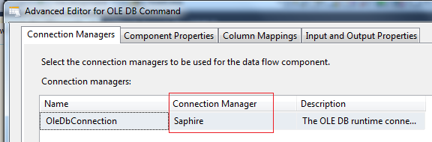

1. **Configure SQL sentence**

UPDATE "dbo"."Atrack_Event_Ticket_DataStaging"

SET EVENT_ID = ?

WHERE TICKET_ID = ?

**OR CALL A STORE PROCEDURE**

**EXEC SP_UPDATE ?, ?**

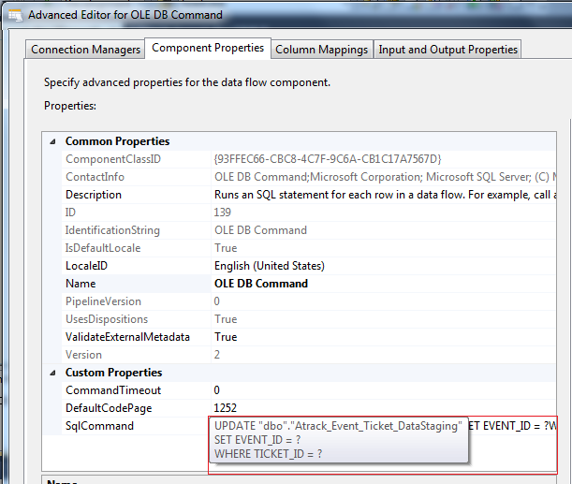

1. **Map the columns to the parameters (Param_0 is the first ‘?’ in the query)**

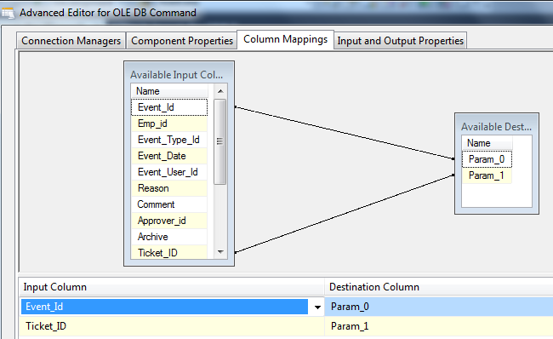

1. **Set type of parameters, int, string, date**

